Team VirtualPhysical

Design Foundation Document

Melissa Cantú, Rachel Gu, Vincent Wu, Michelle Zheng

September 22, 2023

BIOE 451

# Table of Contents

**DESIGN CONTEXT REVIEW 3**

Background Information on Design Environment 3

Information About Customers 4

Applicable Regulations or Standards 4

Technologies That Might Be Used In Our Design 6

Competitive Products or Patents 6

**MARKET ANALYSIS 7**

**IDENTIFYING CUSTOMER NEEDS 12**

**DESIGN SPECIFICATIONS 12**

**REFERENCES 14**

# DESIGN CONTEXT REVIEW

## Background Information on Design Environment

Patients performing a physical for cardiology, pulmonology, and gastroenterology specialties must first be asked to list their medical history, the prescribed and over-the-counter medications they are currently taking, as well as all the symptoms they are having, when they began, their intensity and duration, if they are triggered by anything, and what the patient has done (if anything) to make them better. [1]

The most important signs of cardiac disease in a patient include chest pain, palpitations, shortness of breath, syncope, fatigue, and edema. However, it is important to note that while chest pain is the hallmark symptom of a cardiac disease, it may also result from pulmonary, gastrointestinal, and musculoskeletal disorders. [2] Equipment needed for cardiac physical examinations include a stethoscope and sphygmomanometer (blood pressure cuff). [2]

In a physical exam, inspection, palpation, and auscultation of the heart and vessels is conducted, during which the patient rests on a bed. Inspection involves subjectively observing and recording the general state of the patient, the temperature of the skin, color of nails, and appearance of the pulse on the neck. [2] Palpation includes measuring blood pressure and gathering the rate, rhythm, and characteristics of an arterial pulse by pressing one’s hand against the chest over the heart and on the base of the neck. [3] Lastly, auscultation of heart sounds is performed with a stethoscope, and the examiner listens for S1, S2, S3, and S4 heart sounds in four standard positions: supine, left lateral decubitus, upright, and upright leaning forward. [2]

The most common signs of lung disease are a chronic cough (8 weeks or longer), shortness of breath, chronic mucus production (one month or longer), wheezing, coughing up blood, and chronic chest pain (one month or longer) especially if worsened by breathing in or coughing. [1] Equipment needed for a pulmonary physical examination include nose clips, spirometer, stethoscope, and pulse oximeter. [1]

Lung function tests and spirometry are the most common type of assessment performed in a physical exam. A patient must sit straight with their feet flat on the floor prior to starting a spirometry test. The procedure is as follows: A clip is placed on the patient’s nose, and the patient must place their lips tightly around the mouthpiece connected to the spirometry machine. Then, the patient will take in as deep a breath as possible and then blow out as hard and fast as possible. Testing should be repeated at least three times to obtain the best results. [4]

The most common signs of gastrointestinal diseases include ongoing diarrhea, constipation, frequent or severe heartburn, feeling unusually bloated, sudden or severe abdominal pain, rectal bleeding or blood in stool, difficulty swallowing, and esophageal pain. [5,6] Equipment needed for a gastroenterology exam includes a stethoscope. [7]

In a physical exam, a gastroenterologist will observe a patient’s belly area for any visible masses, auscultate bowel sounds at each quadrant of the abdomen, palpate each of the four quadrants to feel for masses and assess tenderness or pain, and perform a rectal exam to feel for bulges, masses, signs of inflammation, and muscle tone. [7] If further diagnostic tests are required, a patient may be referred to a hospital to undergo an X-ray, CT scan, blood or stool exam, barium swallow, endoscopy, or colonoscopy. [7]

The top 3 *inpatient* electronic medical record (EMR) system vendors are Epic Systems Corporation, Oracle Cerner, and MEDITECH. [8] The top 3 *ambulatory (outpatient)* EHRs are eClinicalWorks, Epic Systems Corporation, and athenahealth. [9] The scope of this project includes ambulatory EHRs only.

The cloud-based eClinicalWorks EMR offers AI speech-to-text technology for documentation; a virtual assistant; HIPAA-compliant integrated telehealth capabilities; and revenue cycle management technology. [10]

Current telemedicine solutions offer the benefits of convenience (no long waiting times, receive medical care at home), improved healthcare access (for those in rural or underserved areas), and cost savings for patients and physicians (For patients: reduced co-pays & deductibles and elimination of travel & parking expenses. For physicians: reduced staff demand, supply expenses, and office space.). However, telemedicine physicals have key limitations, including their focus on primary care as opposed to specialty medicine, a lack of physical examination by a medical technician (which render virtual exams a non-substitute for in-person examination), technical difficulties, and varied insurance coverage. Addressing the gap in the market for virtual *specialty* medicine technology, a product that could record & share quality data from a guided in-person (at a local clinic) physical exam tailored to the specialty of concern and provide a secure & private virtual connection between patient & specialty physician could have the unparalleled advantage of shortening wait times between primary and specialty care visits, thereby improving the efficiency, convenience, and cost of specialty healthcare.

## Information About Customers

Our product will communicate a physical exam performed by a non-physician to a specialty physician, thus the patient will not be involved in the use of our product. As a store-and-forward technology, the specialty physician will interact with the stored data from the physical while the non-physician will use the portion involved with capturing data.

As expanded by U.S. Centers for Medicare & Medicaid Services (CMS) or through the Consolidated Appropriations Act (CAA) of 2023, CMS will provide reimbursement for many telehealth services with Current Procedural Terminology (CPT) codes [11]. Depending on the purpose of the exam (new patient or established patient) and the extent of services provided, our product would fall under multiple CPT codes, which would determine the amount of reimbursement. Our product would fall under Evaluation and Management (E/M) codes which range from 992020 to 99499 [12]. Furthermore, many private insurances cover telehealth services [13].

## Applicable Regulations or Standards

As defined by the Health Resources and Services Administration (HRSA) of the U.S. Department of Health and Human Services (HHS) [14], telehealth is “the use of electronic information and telecommunications technologies to support and promote long-distance clinical health care, patient and professional health-related education, and public health and health administration.” Our product must be compliant with the Health Insurance Portability and Accountability Act of 1996 (HIPAA) which provides standards for the privacy and security of electronic health care with the ultimate goal of protecting patient’s health information [15]. HIPAA details standards for the communication and storage of both paper and electronic records containing sensitive health information [15]. Some vendors that provide HIPAA compliant video communication are Skype for Business/Microsoft Teams, Spruce Health Care Messenger, Cisco Webex Meetings/Webex Teams, and Zoom for Healthcare [16].

The Health Information Technology for Economic and Clinical Health Act of 2009 (HITECH) focused on promoting the adoption and meaningful use of electronic health records; it also expanded upon penalties for HIPAA violations [17]. As defined by the Office of the National Coordinator for Health Information Technology [18], an electronic health record (EHR) is “a digital version of a patient’s paper chart” where “health information can be created and managed by authorized providers in a digital format capable of being shared with other providers across more than one health care organization.” The collaborative nature of an electronic health record differentiates it from an electronic medical record which is used exclusively by one healthcare organization [18]. While making our product compatible with electronic health records is outside of the scope of our product, HITECH delineates standards for the electronic communication of protected health information [17]. Aside from telehealth definition and regulations from federal law, state laws have significant sway in shaping the practice and regulation of telehealth, starting with basic definitions of the terms telemedicine and telehealth.

As defined by the Texas government [19], a “telemedicine medical service means a health care service delivered by a physician licensed in [Texas], or a health professional acting under the delegation and supervision of a physician licensed in [Texas], and acting within the scope of the physician’s or health professional’s license to a patient at a different physical location than the physician or health professional using telecommunications or information technology.” Texas law defines telemedicine and telehealth as two distinct terms. As in [19], Telehealth is “a health service, other than a telemedicine medical service, delivered by a health professional … to a patient at a different physical location than the health professional using telecommunications or information technology.” The key difference between the two definitions is that telemedicine requires the delegation and supervision of a physician. Since our product will employ store and forward technology, which is defined in Texan law [19] as “technology that stores and transmits or grants access to a person’s clinical information for review by a health professional at a different physical location than the person,” where the physician is able to asynchronously review physical exam data, our product is classified as telehealth.

In Texas [19], one of the requirements for telehealth is to “ensure that the informed consent of the patient, or another appropriate individual authorized to make health care treatment decisions for the patient, is obtained before telemedicine medical services… are provided.” Additionally, physicians are required to provide notice of the method by which patients may file a complaint with Texas Medical Board (TMB) [19]. The telehealth service provider must ensure the confidentiality of the patient’s clinical information. Texas state law grants the Texas Medical Board the power to adopt rules to ensure the standard of care for telehealth is comparable to care provided in person [19].

Regarding the safety standards for medical devices, the IEC 60601-1 is an internationally recognized safety and performance standard for electronic medical equipment [20]. Specific to the USA, the Electronic Product Radiation Control Program (EPRC) administered by the Food and Drug Administration (FDA) provides safety standards for any electronic product which “contains or acts as part of an electronic circuit and emits electronic product radiation.” [21]

## Technologies That Might Be Used In Our Design

A device driver is a “specialized software that operates a particular computer-connected device– offering a software interface to the hardware allows operating systems and other computer applications to access hardware functionalities.” [22] Our project will require a driver to connect communication between a EMR web platform (on an application like Safari or Google Chrome) and medical equipment hardware, which will include a stethoscope with audio recording capabilities, a sphygmomanometer, a spirometer, a pulse oximeter, and a camera with video recording capabilities.

However, drivers can only interface with one specific OS for which they were developed. [22] This means that we will have to choose a driver to interface with either Windors, Linus, or macOS. Figure 1 outlines the steps to making device drivers for an operating system.

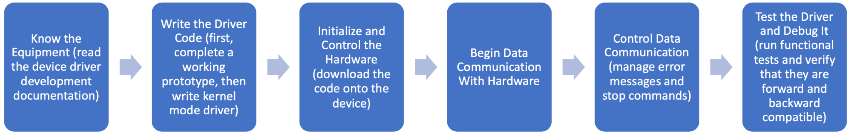

**Figure 1**. Steps to Develop Device Drivers

There are 9 types of drivers: kernel device, user-mode device, character, block drivers, original equipment manufacturer (OEM), virtual device, BIOS, motherboard, and open-source.

The five most popular programming languages for web development are Javascript, HTML5, CSS3, PHP, and Java. [23] Python is another language that has recently gained popularity as a web development tool [24], and since our team all have experience with this language, it might be the most appealing option for our project.

## Competitive Products or Patents

TytoCare offers multiple products aimed at virtual physical exams: TytoHome, TytoPro, and TytoClinic. TytoClinic is designed for remote physical exams in clinics and is the most similar to our product. TytoClinic includes the Tyto device which comes with an exam camera and thermometer, otoscope, stethoscope, and tongue depressor adaptors, pulse oximeter and pressure cuff, iPad with preloaded software, and mobile app and clinician dashboard. HIPAA-secure and FDA approved, TytoClinic allows for the diagnosis and treatment of a wide variety of conditions ranging from respiratory, ENT, cardiac, dermatology, gastroenterology, and general care [25]. However, TytoClinic lacks the functionality of a complete head-to-toe physical exam involving information relevant to specialty physicians.

Another similar product is from Teladoc Health, Primary360 which allows for virtual primary exams from a mobile app by phone or video, connecting patients to 4 types of expert care: primary care, mental health, condition management, and speciality & wellness care. Primary360 offers a blood pressure monitor for patients to keep, but no additional medical devices for diagnosis [26]. There are many products designed to connect patients to doctors, emphasizing 24/7 access to high quality care. Recuro Health and Cirrus MD are two companies offering convenient yet comprehensive virtual care. While these products emphasize the short wait times to connect with a physician (9 minutes for Recuro, and 60 seconds for Cirrus MD), they do not incorporate any medical devices for the diagnosis, relying primarily on private messages or video calls [27,28]. Aside from virtual primary care, there are many products focused on specialized care.

3M Health Information Systems offers specialized digital health products such as MyWoundHealing and iOn Healing. These products remotely monitor complex, hard-to-heal wounds providing real-time wound therapy guidance [29]. In many cases these products include many features outside the scope of our product, such as the integration across multiple healthcare systems.

# MARKET ANALYSIS

Given the projected rise in virtual medicine, our group in the virtual physical exam project will first examine the total addressable market (TAM) of telemedicine. Then, we narrow it down to two segments of specialties - cardiology and gastroenterology - for both the SAM (serviceable addressable market) and SOM (serviceable obtainable market). We have chosen these two because of their relatively large market and accessibility to professionals in these areas for consultation.

For simplicity, we have used a top-down approach to determine the TAM of telemedicine. From previous examples online, it seems typical in telemedicine to start from the patients’ side for the best-case scenario that highlights the overall revenue opportunity to investors; therefore, we would adopt the same approach to calculate TAM in table 1 below. According to the latest data from the United States Census Bureau, the total number of U.S. population is 334,233,854 [30], with 22.5% being the telehealth users (i.e., about 75,202,617 telehealth users), as revealed by the updated national survey in 2021-2022 [31]. Next, the willingness to pay is calculated by multiplying the average cost per visit (using average cost per visit of CVS clinic as the benchmark) by the average number of visits per year (estimated to be four per individual, one for each quarter), which is $400 per person annually. Taken together, TAM is estimated to be roughly $30.1B by multiplying the estimated telehealth market size by the users’ willingness to pay.

| Total number of U.S. population [30] | % Telehealth users [31] | Number of telehealth users | Willingness to pay (avg cost per visit * mean annual #visits) | TAM (Num users * willingness to pay) | Total number of hospitals in the US [32] |
| --- | --- | --- | --- | --- | --- |
| 334,233,854 | 22.5% | 75,202,617 | $100 * 4 = $400 | $30.1B | 6,129 |

**Table 1**. An overview of all data necessary to calculate the TAM of telemedicine.

Since our project concerns the development of a software platform used by medical practitioners for conducting virtual physical exams, in order to calculate our SAM, we need to start from the health providers’ side rather than the patient’' side (as in TAM with a broader scope). We first narrowed down to two specialties, cardiology and gastroenterology, given the ready access to mentor Dr. Abidi (with connections to GI specialists) and sponsor Dr. Wagle (himself a cardiologist by training). Then, by examining the total number of hospitals in the U.S, from American Hospital Association’s data in 2023 [32] and the adoption rate of telehealth by specialty from the study by Vawdrey *et al* in 2022 [33], we arrived at the number of hospitals adopting virtual platforms within the specialty of cardiology and gastroenterology, which is 551 and 2145, respectively, in table 2 below.

To calculate the average annual cost for telemedicine in each specialty (i.e., hospital’s willingness to pay), we subtracted the average annual cost saving using telehealth from the average annual hospital cost in the U.S among telemedicine-adopting hospitals. Specifically, based on Debt.org [34], the average daily cost per hospital in the U.S. is $2,883, by which we multiplied 365 to get the annual cost per hospital. According to McCue *et al*, the annual cost saving per hospital using telehealth is $251,995.49 [35]. Using them, we obtained an annual telemedicine cost per hospital of $800,299.51. Multiply that by the number of U.S. hospitals adopting telehealth for each specialty, we arrived at the SAM of $440,965,030 and $1,716,642,448 for cardiology and gastroenterology, respectively. They each take up 1.47% and 5.70% of the TAM.

| Segments | Adoption rate by specialty (%) [33] | # of U.S. hospitals adopting telehealth by specialty | Average annual hospital cost in the U.S. [34] | Annual cost saving per hospital using telehealth [35] | Average annual cost per hospital for telemedicine | SAM (#hospitals adopting * cost) | % of TAM |
| --- | --- | --- | --- | --- | --- | --- | --- |
| Cardiology | 9% | 551 | $2,883*365 = $1,052,295 | $251,995.49 | $1,052,295-251,995.49 = $800,299.51 | $800299.51 * 551 =$440,965,030 = 441M | 1.47% |
| Gastroenterology | 35% | 2145 | $2,883*365 = $1,052,295 | $251,995.49 | $1,052,295-251,995.49 = $800,299.51 | $800299.51 * 2145 = $1,716,642,448 = 1.7B | 5.70% |
| Total |  | |  |  |  | $2.2B | 7.17% |

**Table 2**. An overview of all data necessary to calculate the SAM of telemedicine within two selected specialties, cardiology and gastroenterology.

| Segments | # of hospitals adopting telehealth in Houston area [36] | Hospitals’ customer base of our interest | Average annual cost per hospital for telemedicine | SOM | %SAM | SOM in first 3 yrs (approx w/ 12.9% CAGR) [37] |
| --- | --- | --- | --- | --- | --- | --- |
| Cardiology | ~300 * 9% = 27 | Rural, with ready access to stable internet | $800,299.51 | $21,608,086 = 21.6M | 4.90% | $359,580 |
| Gastroenterology | ~300 * 35% = 105 | Rural, with ready access to stable internet | $800,299.51 | $84,031,448 = 84.0M | 4.90% | $1398367 |
|  |  | | | $105,639,535 | 4.90% | $175,7947 |

**Table 3**. An overview of all data necessary to estimate the SOM of telemedicine within two specific specialties, cardiology and gastroenterology.

Regarding SOM, the primary factor we consider is the hospital’s geographical location. For the first one to three years, we intend to start with the local hospitals in the Houston area, which are over 300 of them, as shown by Gaziel-Yablowitz *et al* [36]. Multiplying this number with the telemedicine adoption rate per specialty, we obtained that in Houston, there are roughly 27 hospitals adopting virtual cardiology platforms and 105 hospitals adopting virtual gastroenterology platforms. Further multiplying these numbers by the average annual cost per hospital for telemedicine (calculated in table 2 above), we arrived at SOM of $21,608,086 and $84,031,448 for cardiology and gastroenterology, which, after applying for the first three years an estimated compound annual growth rate (CAGR) of 12.9% as *Global Market Insights* reveals [37], are projected to reach $359,580 and $1398367, respectively. Till this point, we have finished all calculations and reasoning behind TAM, SAM, and SOM, and the result for each specialty is summarized below in figure 2.

During the whole process, we primarily considered major hospitals, as we assumed that hospitals are more likely to pay for telemedicine services compared to smaller clinics due to greater money and resources they possess, based on Dr. Black’s feedback. We also assumed that these hospitals are willing and able to capture a sizable portion of market from the households living in rural areas with stable internet access, since according to Leung’s research, longer travel distance is associated with a higher willingness-to-pay by these people [38], who constitute to a major part of hospitals’ customer base in telemedicine market. Lastly, we assumed for simplicity that patients considered do not have any health insurance coverage.

Our primary end users are the non-physicians. To accommodate them, we have brainstormed several approaches on device modifications. Concerning cardiology, we have proposed a digital stethoscope - rather than a traditional stethoscope - with a monitor on display, which allows for real-time heart rate monitoring and anomaly detection. This approach ensures that even the auditorily impaired can utilize the device and carry out the cardiological exam. On the other hand, we will still employ the classic, non-digital protocol for gastroenterology exam, relying on qualitative metrics and numeric scales for patient evaluation. Once it is finalized, the results will be input and integrated into the software platform, ensuring both patient convenience and data privacy. Thus, through meticulous planning and by placing the end-user at the core of our strategy, we aim to not only tap into the vast potential of telemedicine but also pioneer changes that truly resonate with users’ needs.

We have also assessed a list of competitors in two specialties with their respective characteristics in table 4 below. Overall, compared to traditional hospitals, telehealth platforms as a whole offer patients 24/7 access and virtual, more flexible services. However, most telehealth are not specialized and incapable of carrying out real-time virtual physical exams online. Among all, the most versatile telemedicine service is TytoCare, which integrates AI-powered software and hardware to perform a range of physical exams on heart, lung, ear, skin, abdomen, and throat. In terms of specialty, the most notable two companies in the cardiology sector are Heartbeat Health and Idovan, with the latter more AI-driven and HER-integrated than the former. In gastroenterology, the major players are Oshi Health and GI Alliance virtual platforms. Given the current progress, the tools and services developed so far only cover part of the entire relevant physical exam for most specialties in medicine. In this light, a complete, head-to-toe, user-friendly platform to deliver a reliable virtual physical exam is still lacking, and that is what we will be striving for.

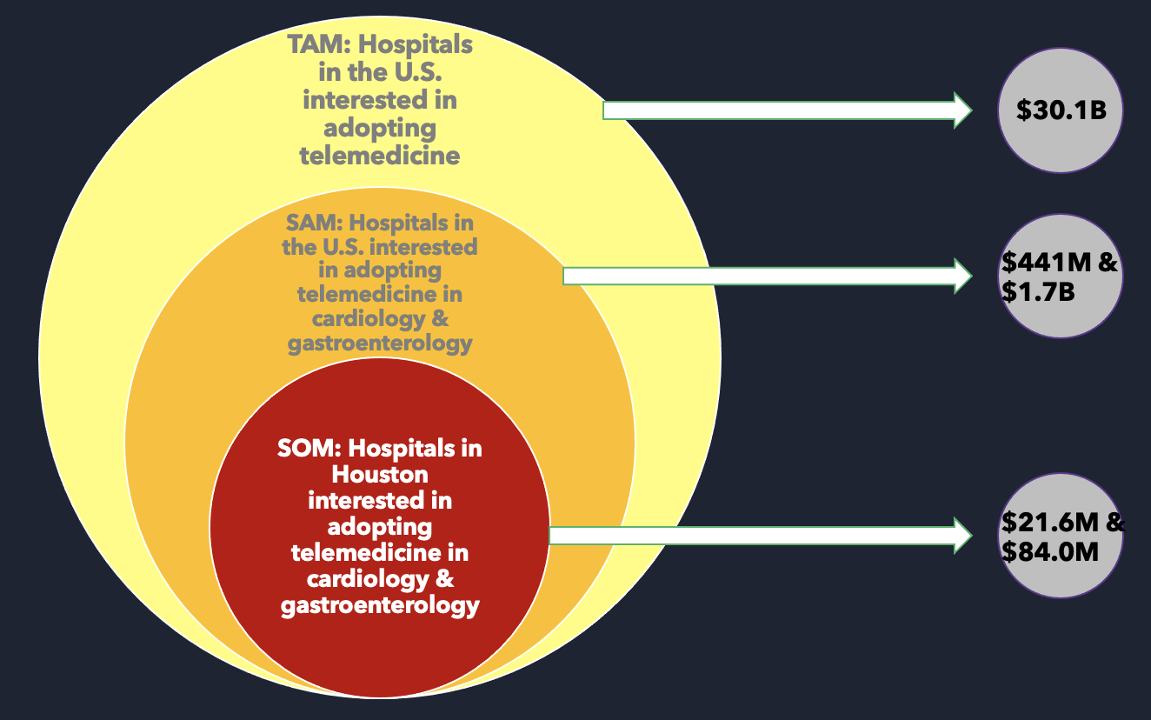

**Figure 2**. The Venn diagram of TAM, SAM, SOM, calculated for specialties of cardiology and gastroenterology.

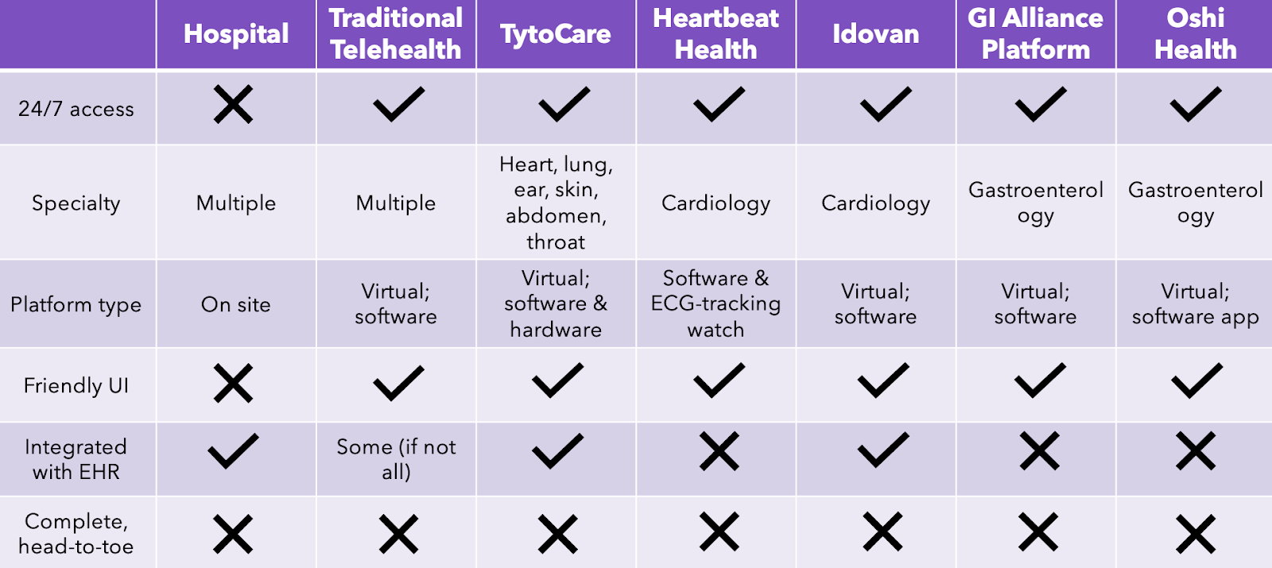

**Table 4**. A competitive analysis of different telehealth platforms, hospitals, and how they compare with each other in terms of characteristics, strengths, and weaknesses.

# IDENTIFYING CUSTOMER NEEDS

We have a variety of stakeholders for our device: the patient, the non-physician conducting the physical exam, the specialty physician receiving the exam results, and the product buyer.

For patients, the device must accommodate patients with disabilities and for non-physicians, the EMR user interface must be easy to navigate. For specialty physicians, the user needs are that the web-based platform provides quality/accurate data, is accessible to clinicians with disabilities such as hearing loss, and the user interface is intuitive. Finally, for buyers and stakeholders, there must be quality management of data ensuring that the information is accurate, audible, and visible so that the doctor or clinician can trust the results provided by the virtual physical exam; the web-based platform is close to an in-person appointment experience at the speciality clinic; is easy to maintain with security updates; backup and disaster recovery; and the admin is able to manage the manage user accounts, including creating and deleting user accounts, reset password, and managing permissions.

The regulatory and standard needs are that the web-based platform complies with FDA and FCC regulations, complies with ISO standards for medical devices such as risk management, biocompatibility and medical device software and follows the EMR systems format that are currently used by non-physicians to record medical data.

Our team conducted interviews with speciality physicians from Kelsey-Seybold clinic who would be the users of our product. We asked Dr. Tushar Dharia, a physician specializing in gastroenterology, about the process and limitations of virtual physical exams in his profession. He explained that important measures in gastroenterology exams are body mass index (BMI), visual examination (eyes, skin, muscle structure, breathing, oral signs, and touch related measures. Dr. Dharia conveyed that difficulties with the virtual physical exam included that touch related measures were relative and difficult to convey virtually and snapshot data is often unhelpful, especially for new patients. In his experience, 10-15% visits are telemedicine through video or phone and video telemedicine visits are dependent on patient wifi where they have to switch back to phone call 50% of the time. Currently, at Kelsey-Seybold clinic, the platform that is being used by specialty physicians for uploading EMR data is Epic where key features are taking screenshots, using phone for video/phone call and being able to update charts on laptop and having the same template for patient charts in the office.

# DESIGN SPECIFICATIONS

The design specifications include number of cycles on accelerated wear testing of the sphygmomanometer before failure that has a high technical risk and target value of 150M to ensure that the medical devices connected to the web based platform will uphold the clinical condition and safety of patients. There will also be specifications to measure the total cost involved with patient care including transportation, co-pay/deductibles with an ideal range of $50-70, other costs with medium complexity.

There will also be specs measuring the non-physician and speciality physician interaction with the software platform and whether it fulfills their expectations of providing accurate diagnoses and information of patients and being intuitive and easy to navigate. This would be measured in the form of usability tests for the non-physician and the speciality physician on a scale from 1 to 5 where the specification is low complexity and the ideal value on the usability test is ≥ 4.

To measure the accuracy of the data from the medical device connected to the software platform, our team will test out the data received from a sphygmomanometer on a sample of 10 people with the data from a commercial device where the ideal error would fall within 5% and be of medium complexity. To ensure that the web-based platform is easy to maintain with security updates, backup and disaster recovery, our team will test the number of HIPAA privacy risks that occurred where the complexity will be high because there are many different ways to measure it, for example, if patient confidential information is breached.

# 

# REFERENCES

[1] A. L. Association, “Warning Signs of Lung Disease.” https://www.lung.org/lung-health-diseases/warning-signs-of-lung-disease (accessed Sep. 21, 2023).

[2] M. B. Malik and A. Goyal, “Cardiac Exam,” in *StatPearls*, Treasure Island (FL): StatPearls Publishing, 2023. Accessed: Sep. 21, 2023. [Online]. Available: http://www.ncbi.nlm.nih.gov/books/NBK553078/

[3] *MedSim -Cardiovascular System Palpation*. Accessed: Sep. 21, 2023. [Online Video]. Available: https://www.youtube.com/watch?v=ExCH7PWo4iY

[4] *How to perform a spirometry test*. Accessed: Sep. 21, 2023. [Online Video]. Available: https://www.youtube.com/watch?v=EXJ279tpcQ4

[5] “7 Signs It’s Time to See a Gastroenterologist.” https://www.houstonmethodist.org/blog/articles/2022/feb/7-signs-its-time-to-see-a-gastroenterologist/ (accessed Sep. 21, 2023).

[6] GSGIadmin, “What to Expect at your Gastroenterologist Appointment,” *Granite State Gastroenterology*, Jun. 04, 2021. https://granitegastro.com/what-to-expect-your-gastroenterologist-appointment/ (accessed Sep. 21, 2023).

[7] K. Silva, “Your First Appointment with a Gastroenterologist: What to Expect,” *inSite Digestive Health Care*, Apr. 30, 2021. https://www.insitedigestive.com/2021/04/30/your-first-appointment-with-a-gastroenterologist-what-to-expect/ (accessed Sep. 21, 2023).

[8] “10 most common inpatient EHR systems by market share | Definitive Healthcare.” https://www.definitivehc.com/blog/most-common-inpatient-ehr-systems (accessed Sep. 21, 2023).

[9] “Top 10 ambulatory EHRs | Definitive Healthcare.” https://www.definitivehc.com/blog/top-ambulatory-ehr-systems (accessed Sep. 21, 2023).

[10] eClinicalWorks, “EHR,” *eClinicalWorks*. https://www.eclinicalworks.com/products-services/ehr/ (accessed Sep. 21, 2023).

[11] “AMA telehealth policy, coding & payment,” *American Medical Association*, Jul. 19, 2023. https://www.ama-assn.org/practice-management/digital/ama-telehealth-policy-coding-payment (accessed Sep. 21, 2023).

[12] “Private insurance coverage for telehealth | Telehealth.HHS.gov.” https://telehealth.hhs.gov/providers/billing-and-reimbursement/private-insurance-coverage-for-telehealth (accessed Sep. 21, 2023).

[13] “Evaluation and Management (E/M) Coding,” *American Medical Association*, Sep. 06, 2023. https://www.ama-assn.org/topics/evaluation-and-management-em-coding (accessed Sep. 21, 2023).

[14] Office for Civil Rights (OCR), “What is telehealth?,” *HHS.gov*, Mar. 27, 2020. https://www.hhs.gov/hipaa/for-professionals/faq/3015/what-is-telehealth/index.html (accessed Sep. 21, 2023).

[15] Office for Civil Rights (OCR), “HIPAA for Professionals,” *HHS.gov*, Sep. 10, 2015. https://www.hhs.gov/hipaa/for-professionals/index.html (accessed Sep. 21, 2023).

[16] “Telehealth for Providers: What You Need to Know.” U.S. Department of Health and Human Services, May 2023. [Online]. Available: https://www.cms.gov/files/document/telehealth-toolkit-providers.pdf

[17] “Excerpts from the American Recovery and Reinvestment Act of 2009 (ARRA).” Office of the National Coordinator for Health Information Technology (ONC). [Online]. Available: https://www.healthit.gov/sites/default/files/hitech_act_excerpt_from_arra_with_index.pdf

[18] Office of the National Coordinator for Health Information Technology (ONC), “What is an electronic health record (EHR)? | HealthIT.gov.” https://www.healthit.gov/faq/what-electronic-health-record-ehr (accessed Sep. 21, 2023).

[19] “OCCUPATIONS CODE CHAPTER 111. TELEMEDICINE, TELEDENTISTRY, AND TELEHEALTH.” https://statutes.capitol.texas.gov/Docs/OC/htm/OC.111.htm (accessed Sep. 21, 2023).

[20] “IEC 60601: Product Safety Standards for Medical Devices.” https://www.intertek.com/medical/regulatory-requirements/iec-60601-1/ (accessed Sep. 21, 2023).

[21] Center for Devices and Radiological Health, “Electronic Product Radiation Control Program,” *FDA*, Feb. 23, 2023. https://www.fda.gov/radiation-emitting-products/electronic-product-radiation-control-program (accessed Sep. 21, 2023).

[22] “9 Types of Device Drivers and Their Applications,” *Spiceworks*. https://www.spiceworks.com/tech/devops/articles/what-is-device-driver/ (accessed Sep. 21, 2023).

[23] “Best Programming Languages for Web Development | Computerscience.org,” Sep. 28, 2022. https://www.computerscience.org/bootcamps/guides/programming-languages-web-development/ (accessed Sep. 21, 2023).

[24] javinpaul, “Top 5 Programming languages for Web development in 2023,” *Javarevisited*, Jan. 14, 2023. https://medium.com/javarevisited/top-5-programming-languages-for-web-development-in-2021-f6fd4f564eb6 (accessed Sep. 21, 2023).

[25] “TytoCare,” *TytoCare*. https://www.tytocare.com/ (accessed Sep. 21, 2023).

[26] “Virtual Primary Care & Online Doctor Visits.” https://www.teladochealth.com/expert-care/primary-care/ (accessed Sep. 21, 2023).

[27] “Product: Virtual Primary Care - Recuro Health,” Apr. 29, 2022. https://recurohealth.com/virtual-primary-care/, https://recurohealth.com/virtual-primary-care/ (accessed Sep. 21, 2023).

[28] “Our Platform,” *Impactful Virtual Primary Care*. https://www.cirrusmd.com/our-platform (accessed Sep. 21, 2023).

[29] “The Future of Telemedicine,” *3M Futures*. https://futures.3m.com/The-Future-of-Telemedicine (accessed Sep. 21, 2023).

[30] Bureau, US Census. “U.S. Population Estimated at 334,233,854 on Jan. 1, 2023.” *Census.gov*, 29 Dec. 2022.

[31] Lee, Euny C. , et al. *Updated National Survey Trends in Telehealth Utilization and Modality (2021-2022)*. ASPE Office of Health Policy, Mar. 2022.

[32] American Hospital Association. “Fast Facts on U.S. Hospitals, 2019 | AHA.” *American Hospital Association*, 2023.

[33] Vawdrey, David K., et al. “Pandemic Telemedicine Adoption Trends in a Predominantly Rural Integrated Health System.” *AMIA Annual Symposium Proceedings*, vol. 2022, 29 Apr. 2023, pp. 1101–1107.

[34] “Hospital and Surgery Costs – Paying for Medical Treatment.” *Debt.org*, Accessed 21 Sept. 2023.

[35] Snoswell, Centaine L., et al. “Determining If Telehealth Can Reduce Health System Costs: Scoping Review.” *Journal of Medical Internet Research*, vol. 22, no. 10, 19 Oct. 2020, p. e17298.

[36] Gaziel-Yablowitz, Michal, et al. “Telehealth in US Hospitals: State-Level Reimbursement Policies No Longer Influence Adoption Rates.” *International Journal of Medical Informatics*, vol. 153, Sept. 2021, p. 104540. Accessed 31 July 2021.

[37] “Telemedicine Market Share Report | Global 2020-2026 Industry Data.” *Global Market Insights, Inc*.

[38] Chua, Valerie, et al. “The Willingness to Pay for Telemedicine among Patients with Chronic Diseases: Systematic Review.” *Journal of Medical Internet Research*, vol. 24, no. 4, 13 Apr. 2022, p. e33372, https://doi.org/10.2196/33372.